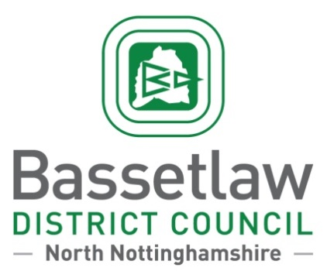
PRESS RELEASE
Queen’s Buildings, Potter Street, Worksop, Nottinghamshire, S80 2AH
Tel: (01909) 533726 Fax: (01909) 501758

Contact: Will Spence Date: 01/07/2016
Senior Communications Officer
Tel: 01909 533 721 Ref: PR 2128
Devolution: Have Your Say
Bassetlaw Residents are being asked for their views on a devolution deal that could allow for powers and decisions on millions of pounds worth of funding to be made locally, instead of by Government officials in London.
Following a decision by Councillors in March, Bassetlaw District Council has applied to be a full member of the Sheffield City Region (SCR), which has already negotiated a deal with the Government to make local decisions on how £900 million in funding over the next 30 years is spent, in addition to an additional £484 million over the next five years.
This funding would be used to create jobs, invest in housing, and create training opportunities for local people. But before this can be approved by Government, the SCR and the Council must first consult with residents.
The consultation runs from 1st July until 12th August and is available online via,www.sheffieldcityregiondevolution.org.uk in addition to consultation events that will be taking place across the district over the next six weeks.
Cllr Simon Greaves, Leader of Bassetlaw District Council, said:
“This is about our economy and what is best for Bassetlaw businesses and residents. It’s about creating opportunities, jobs and training prospects and securing sustainable economic growth and investment for the foreseeable future. We believe that these interests are best served by being a full member of the Sheffield City Region.
“Having a seat at this table will ensure that we receive our share of £1.3 billion of funding. This is a significant amount of investment and instead of being at the back of the queue and having Government officials in London decide how this is spent, local decision makers will be able to decide how the money is invested in local projects. We will use our voice to champion rural businesses so that our villages don't lose out and we will fight hard for projects and schemes to bring more jobs and investment to Retford. We will continue to develop projects in Worksop and Harworth and seek opportunities for Tuxford and the Trent Valley."
“Before this process can happen we must first seek the views of Bassetlaw residents through a formal consultation process and I would ask that as many people as possible fill in the survey.”
Just some of the projects in Bassetlaw to have already received almost £1M of funding from Sheffield City Region include road and infrastructure projects in Worksop and Harworth that will unlock sites for regeneration and growth, which will in turn help to create up to 1,350 new jobs.
“This is not about Bassetlaw leaving Nottinghamshire,” added Cllr Greaves. “We are proud of our history and will remain within the geographical boundaries of the County irrespective of what happens next.
“The Council will retain its sovereignty over the services we provide, such as refuse collection, street cleaning, housing and markets, and we will continue to work closely with our partners at the County Council.”
There will also be public meetings in Worksop on the 18th July and Retford on the 22ndJuly for residents and businesses to find out more. Details of these will be announced shortly.
If you would like to take part in the consultation, please visit www.sheffieldcityregiondevolution.org.uk.
Paper copies of the consultation will also be available at the Council’s offices at Queen’s Buildings, Worksop and the One-Stop-Shop in 17b The Square, Retford.
The final decision on whether Bassetlaw can be a full member of the Sheffield City Region Mayoral Combined Authority and share the benefits of the devolution deal will be made by the Secretary of State for the Communities and Local Government in the autumn ahead of mayoral elections in May 2017.
[ENDS]

