Lound Parish Council

Draft Minutes of the Parish Council meeting held on Tuesday 24th April 2018 at 7.30pm in the Village Hall.

Present: Cllrs: J. Powell, A Perkins, A. Jones, R. Austin, J. Wilkinson – chairperson.
County and District Cllr: T. Taylor.
Clerk: C. Challener,

Residents: None.
04.18.01 Apologies for absence: Cllr M.Holgate:

04.18.02 Meeting adjourned for Public Discussion, Police Report.

See reports from Other Committees for Policing information.

Nuisance Dogs – LPC to formally write to Julian Proudman the Principal Environmental Health Manager at BDC to express their concerns in relation to the various dog complaints and reports of attacks.
Action Clerk

Donkey Lane – ownership of Donkey Lane queried. BDC to be contacted to validate the suggestion that the land is unowned.
The land locked field which the lane leads to is being used for (reports) of motorbike/recreational use. The land was previously used as grazing land and therefore a Planning application should have been submitted in regard to a change of purpose. Confirmation of whether this has been granted required.
Action Clerk

Annual Parish Meeting – Agenda agreed.
Annual Parish Council Meeting (AGM) – Agenda agreed.

Both to be circulated as normal practice shortly. (See separate communication)
Action Clerk

Idle Valley Group – attendance required from LPC. A resident currently in attendance of the IVG meeting to be asked if they would provide a quarterly report (or as necessary) to LPC, who will then support and provide feedback as required. A trial period of 1 year suggested to ensure the process works for all involved.
Action M. Holgate

04.18.03 Declarations of Interest and Confidentiality.
Cllr J. Wilkison declares planning application for consideration.
Clerk C. Challener declares planning application for consideration.

04.18.04 Minutes of Meeting
Meeting held on 27th March 2018 signed by Cllr J. Powell as a record of true and accurate proceedings.

04.18.05 Matters Arising:
Outstanding from previous minutes - Transfer Lengthsman to LPC control
Action T.Taylor

04.18.06 Reports from County and District Councillor
Outstanding from previous minutes - Waiting for news on speed signage, road signs.
Action T.Taylor

C&D Cllr T. Taylor reports that Worksop Police Station is to close. The policing unit will be housed within Queens Building, Worksop (the Council offices).

In direct support of the Dog issues Lound is experiencing, C&D Cllr T. Taylor has contacted Julian Proudman the Principal Environmental Health Manager at BDC. T.Taylor has raised concerns, provided supporting evidence and expressed the importance of a resolution. She is actively communicating with the Environmental Health Manager and will continue to provide updates of progress made on the situation.

A County and District motion has been passed to cease the use of single use plastics where practical and costs allow.

The Viola recycling plant was visited, and it noted that a number of items were being labelled as not being recyclable, where it fact they could be, but the cost of them being recycled made it unviable.
It was also noted that a lot of ‘bad waste’ was entering household recycle bins which was disappointing and meant resources were being spent by manually having to pick this ‘bad waste’ out from the recyclable material.

04.18.07. Health and Safety & GDPR

Health & Safety
Assessment performed by: Cllr J. Wilkison.
Findings were:
Slides in the Young Peoples area may need painting shortly as is rust showing. This is to be monitored monthly to see if the problem worsens.
Moss/Algae growing on various areas of play equipment. Sign required to warn of potential hazard.
Action Clerk
Sign on gate needs removing and replacing with up to date information.
Action R.Austin to remove. Clerk to source new sign

Playing Field trees are in growth again and will require a Summer cut to ensure they are safety compliant. To be monitored.

Next Playground Audit to be performed by Rob Austin.
Action Rod Austin

GDPR

Rod provides presentation for consideration detailing the GDPR requirements.

Clerk asks all Councillors to complete the GDPR Security Compliance Checklist and to return at the next meeting.
Action All

Rod asks all Councillors to consider for data mapping purposes what information they are holding.
Action All
New GDPR policies to be circulated for review at the next meeting.
Action Clerk

04.18.08 Finance

LPC Bank Reconciliation:
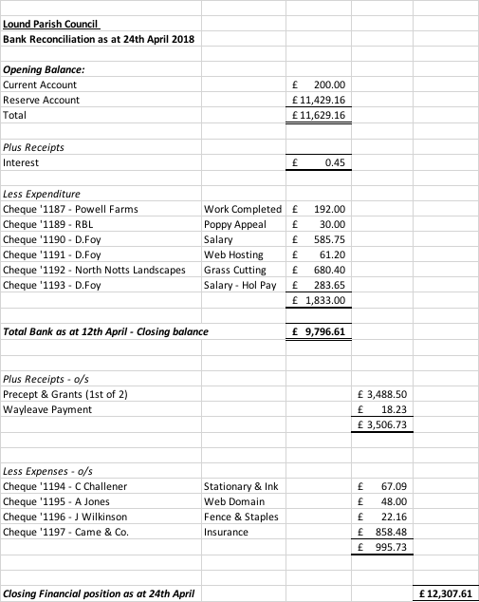

Linghurst Lakes.

No movements since the previous month.

04.18.9. Tree Warden & Footpath Wardens.
The next Village Green working party will be on the 27th May – all are welcome.
Crier to advertise.
Action A. Jones

Daffodils to be costed (late Summer/Autumn time) and to be planted on the opposite side to the playing field where the ‘Daffodil verge’ is shorter than the other side, essentially providing symmetry.
Action J. Wilkinson

04.18.10. Correspondence
None

04.18.11 Planning issues Applications:
CC and JW leave the room for the remaining Councillors to further discuss due to a conflict of interest.

- Consultation 18/00406/CAT – Tree Fell & Tree reduction at 99 Town Street.
- Consultation 18/00406/CAT – Tree Fell at Grove Farm, 101 Town Street.

Decision: Support - No issues with planning proposals raised.

CC and JW enter the room.

- Consultation 18/00488/RSB Erect New Dwelling and new Access (Resubmission)
Decision: Support - No issues with planning proposals raised.
Planning permission 1/16/00773/CDM - DISCHARGE OF CONDITIONS 8, 22 AND 33 iGas Energy Supply
Decision: Neither for or Against.
04.18.12 Reports from Other Committees

Cllr J. Powell attended the Police Priority Meeting.
The meeting was well attended.
Samantha Pearson was present as the new Sargent.
Inspector Bellemy chaired the meeting, commenting that the New Chief Constable was making changes to bring various functions back in house, moving towards common sense policing and breaking the recent grouping of Counties policing structure.

Crime was reported as roughly the same month on month.

The police will be focusing on Quad bikes and Poaching within the area.
Fly Tipping issues are to be addressed by Bassetlaw District Council.

Cllr J. Powell contacted Sargent Sam Pearson after the meeting asking what support they were giving in relation to the Dog issues within the village. The response was that as the Dog Warden (bite) complaint had been dropped there was little they could do at this moment in time.

At the next meeting, LPC is to ask how Cybercrime is being captured and reported.

04.18.13 Village Update / Matters to Report
A. Jones is to step down after 27 years from the Village Committee. R. Austin will resume the position as representative.

It has been requested that Charcon be approached to see if they have the use of Portaloos and if so could they be made available for the Lound Summer Fete.
Action Clerk
Grass cut on the playing field to be arranged prior to Summer Fete (Midsummer Madness) for week commencing 18th June.
Action Clerk

A. Jones reported a fly tipping incident on Daneshill. Alan noted the lack of ownership by BDC who reported it was the responsibility of the land owner to clean it up.

The Village website host company ownership was recently taken over and as a result a data migrated to a new server. This unfortunately resulted in the website going down for a period of time. There are still some issues being addressed and will hopefully be resolved shortly.

02.18.14. Date of the next Parish Council Meeting

Annual Parish Meeting - Saturday 19th May 2018 – 3.00pm

Annual Parish Council Meeting - Tuesday 22nd May 2018 – 7.00pm Chair J. Wilkinson

(Ordinary) Parish Council Meeting Tuesday 22nd May 2018 – 7.30pm Chair J. Wilkinson

Mrs Claire Challener – Clerk, Tel: – 01777 816952 07557104323
E-mail – loundparish@outlook.com, www.loundvillage.co.uk

__________________________________________________________________________________________
Circulation: C & D Cllr T Taylor, M. Holgate, A. Jones, A Perkins, J Powell, J Wilkinson, R Austin.
PCSO Lucy Campion, Martin Fisher (Idle Valley), Notice board, files, website.

NB: Minutes subject to approval at the next meeting

PLEASE CONTACT A COUNCILLOR OR THE PARISH CLERK IF YOU NEED ANY FURTHER INFORMATION

