Friends of DANESHILL LAKES Local Nature Reserve
Daneshill Road, Torworth, Retford DN22 8RB

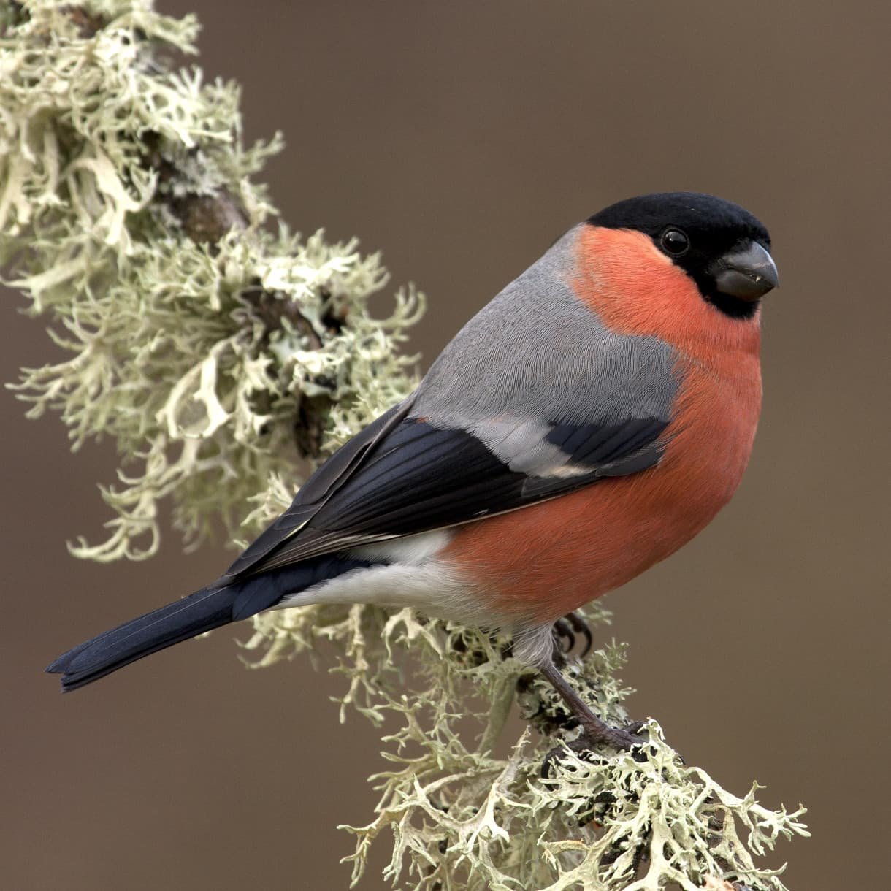
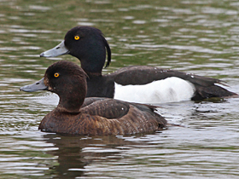
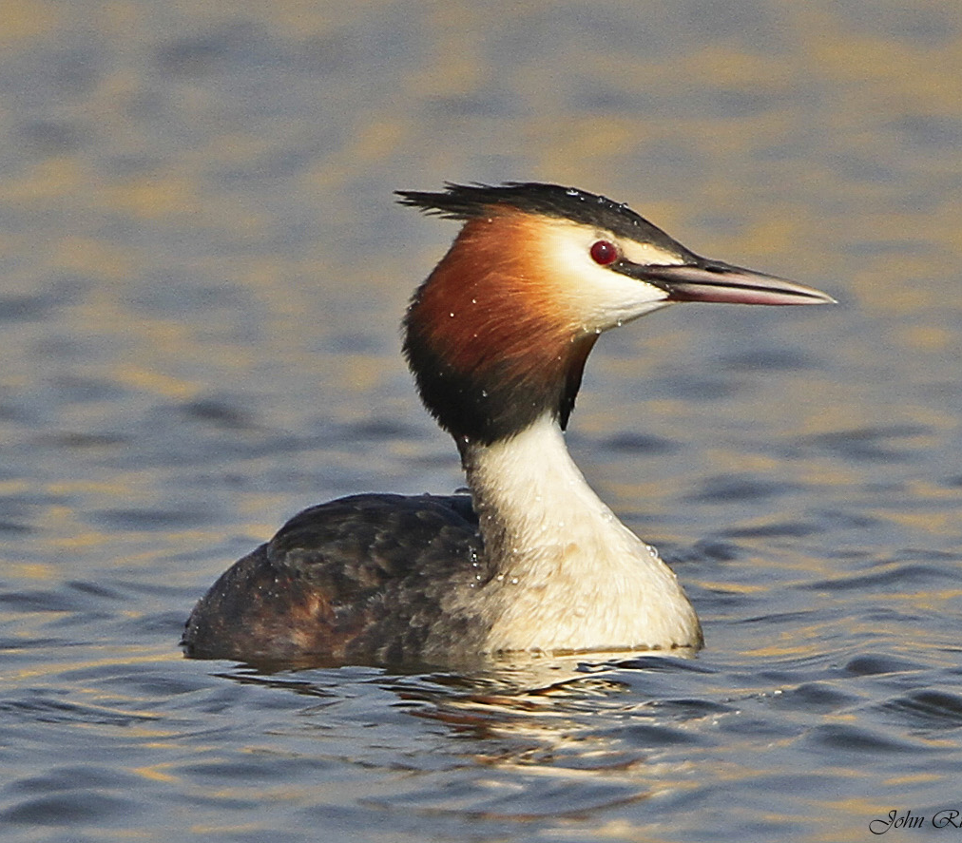

BIRD WALK
Sunday 9th February 10 am to 12 noon meet in car park at 9.45 am

Aimed at spotters of all ages and abilities Get some easy bird identification tips Free event - No booking required - Binoculars available
Further information from Lesley Noar - daveandlesnoar@outlook.com/01777 818362 Website: friendsofdaneshilllakes.btck.co.uk

