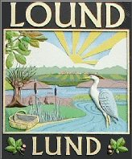

Lound Parish Council
Annual Parish Meeting.

The Annual Meeting of the Parish will be held on 1st May 2021 at 1.00pm by virtual Zoom meeting.

This is an open forum for the village and members of the public to attend.
All are welcome.

Events & Agenda

- Chairperson’s Welcome: Chairperson

- Apologies

- Chairperson report 2020-2021: by Cllr Pauline Sheehy

- Linghurst Lakes report: by Jerry Kershaw

- Neighbourhood Plan update and opportunity to ask questions

- Any other business

Mrs Claire Challener – Clerk, Tel: – 01777 816952 07557104323
E-mail – loundparish@outlook.com, www.loundvillage.co.uk
__________________________________________________________________________________________
PLEASE CONTACT A COUNCILLOR OR THE PARISH CLERK IF YOU NEED ANY FURTHER INFORMATION

